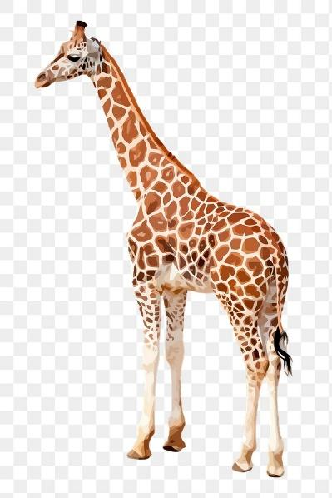

<https://encrypted-tbn0.gstatic.com/images?q=tbn:ANd9GcSdHWj2m0jnXuntXEHC_VquO-7HKCG0huX6jQ&usqp=CAU>

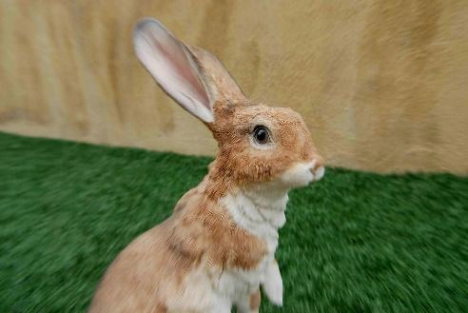<https://live.staticflickr.com/1117/1479591446_df6d585d1c_b.jpg>

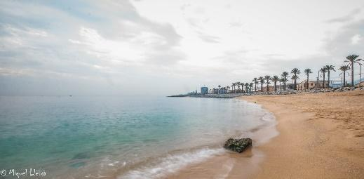

<https://live.staticflickr.com/696/23352917220_d3820922f4_b.jpg>

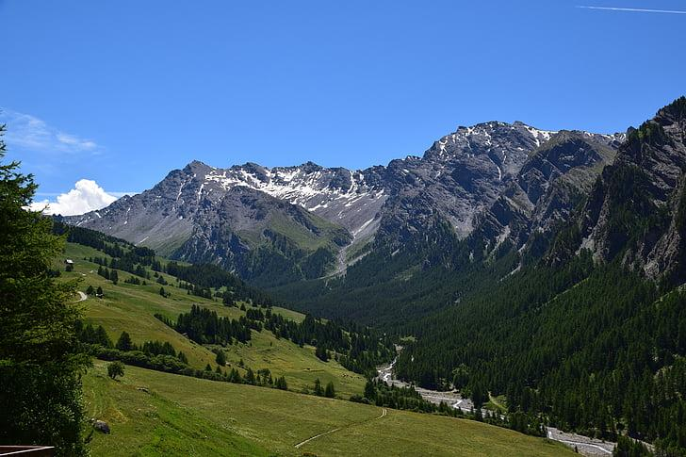

<https://i0.hippopx.com/photos/808/335/766/view-st-veran-valley-landscape-preview.jpg>

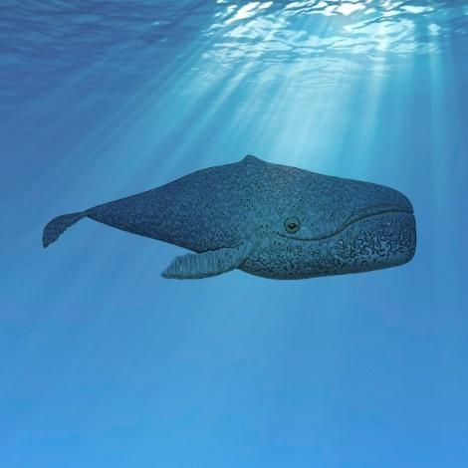

<https://www.publicdomainpictures.net/pictures/270000/nahled/whale-in-water.jpg>

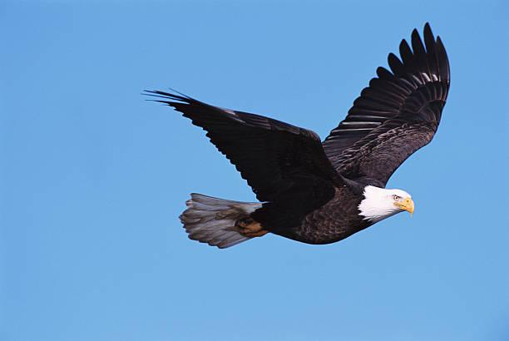

<https://media.gettyimages.com/photos/bald-eagle-in-flight-side-view-picture-id200022121-001?k=20&m=200022121-001&s=612x612&w=0&h=yF3tZmBJoHuvDy1pqP2-gsVAoxdiMmdrD3i0mAm3zy4>=

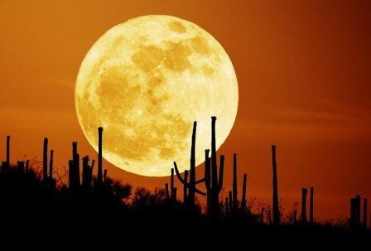

<http://www.jouscout.com/astro/ssolar/imatges/529%20Lluna.jpg>

Castell de sorra:

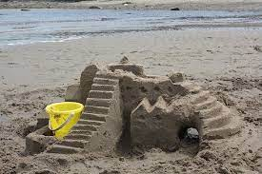

<https://i0.hippopx.com/photos/373/958/557/castle-sand-sea-preview.jpg>

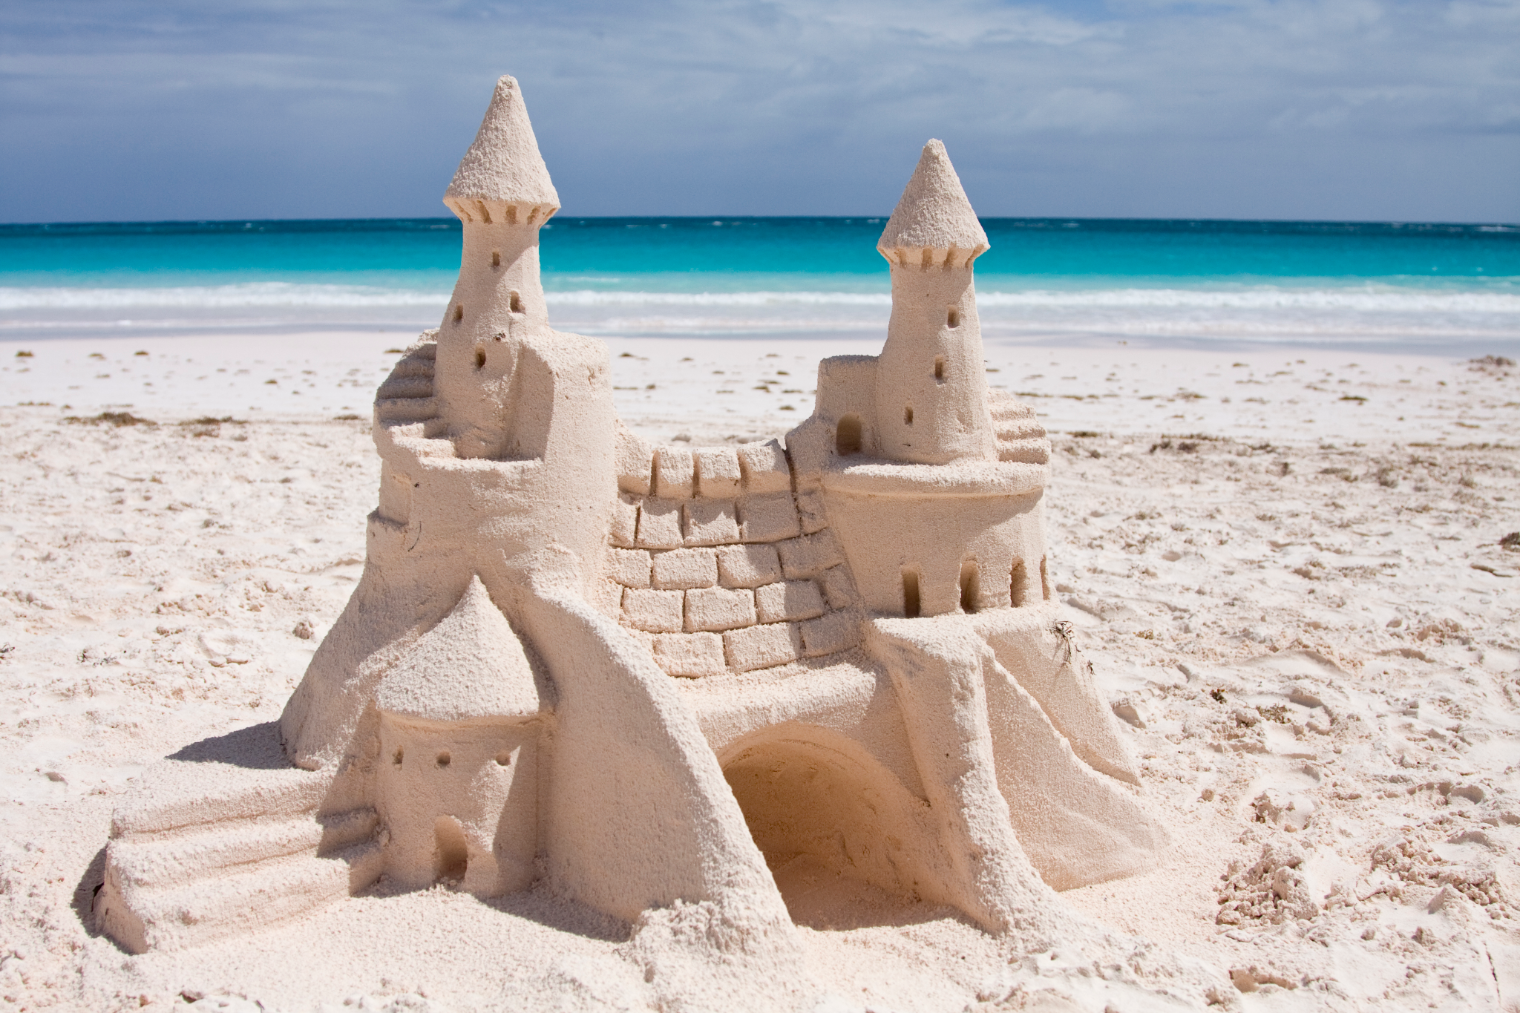

<https://upload.wikimedia.org/wikipedia/commons/7/77/Sand_castle_on_Harbour_Island_2011.jpg>

Castell de Montfulleda:

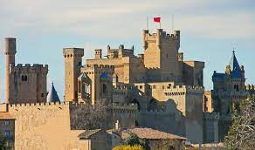

(Castell d’olite)

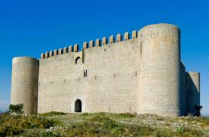

(Castell de Montgrí)

https://www.google.com/url?sa=i&url=https%3A%2F%2Fwww.flickr.com%2Fphotos%2F7455207%40N05%2F5246140640&psig=AOvVaw22OX_MDNW4KR60QPEqPEOx&ust=1669994240193000&source=images&cd=vfe&ved=0CBAQjRxqFwoTCKjGjMnb2PsCFQAAAAAdAAAAABAL

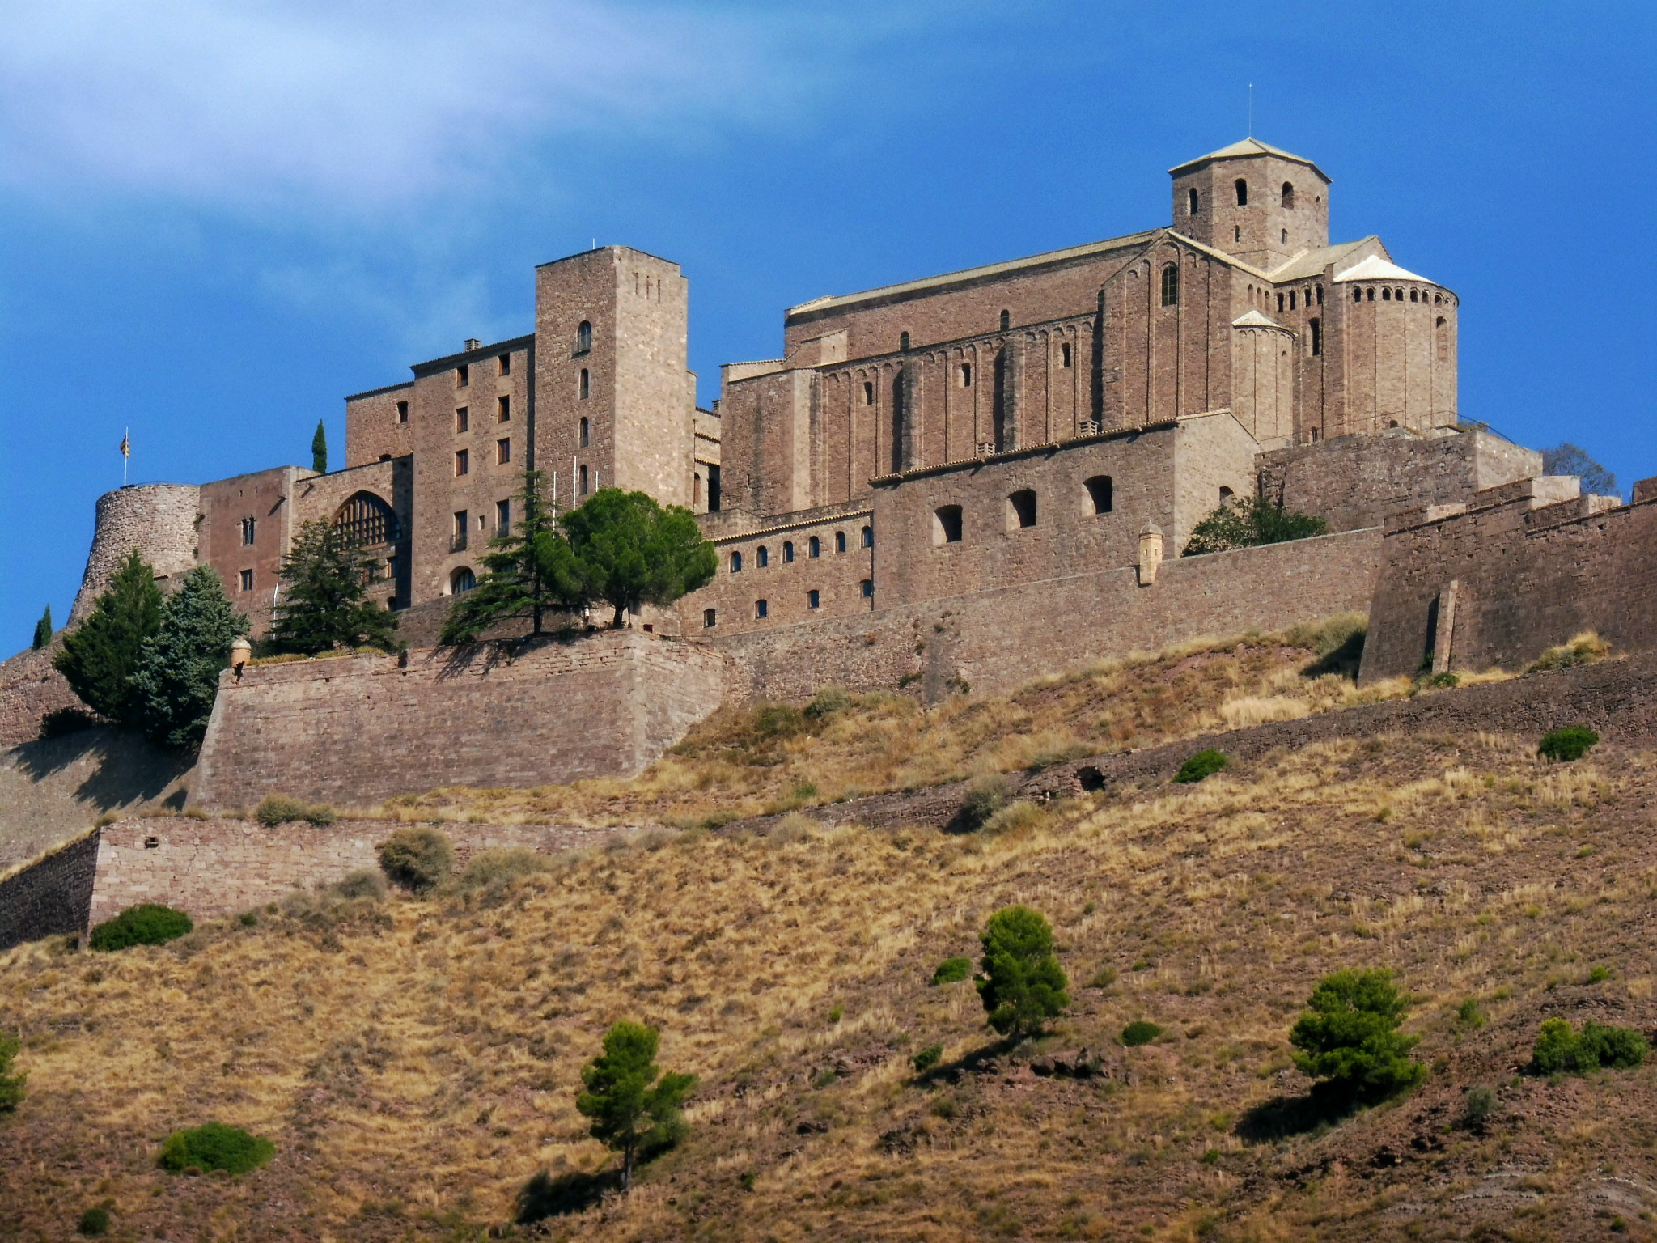

(Castell de Cardona)

https://www.google.com/url?sa=i&url=https%3A%2F%2Fcommons.wikimedia.org%2Fwiki%2FFile%3ACASTELL_DE_CARDONA_-_IB-803.jpg&psig=AOvVaw22OX_MDNW4KR60QPEqPEOx&ust=1669994240193000&source=images&cd=vfe&ved=0CBAQjRxqFwoTCKjGjMnb2PsCFQAAAAAdAAAAABAG

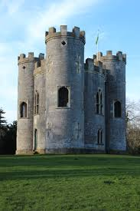

<https://encrypted-tbn0.gstatic.com/images?q=tbn:ANd9GcSFYPOUtAg65RQObMYXhUbdoqqBSOGQQYcJkA&usqp=CAU>

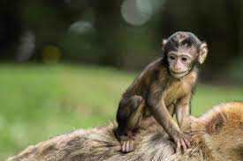

https://www.google.com/imgres?imgurl=https%3A%2F%2Fget.pxhere.com%2Fphoto%2Fanimal-wildlife-wild-zoo-young-mammal-care-dam-monkey-baby-fauna-primate-chimpanzee-baboon-vertebrate-monkey-family-salem-macaque-old-world-monkey-barbary-ape-monkey-mountain-monkey-baby-common-chimpanzee-new-world-monkey-936313.jpg&imgrefurl=https%3A%2F%2Fpxhere.com%2Fes%2Fphoto%2F936313&tbnid=ML3VQ8gp1gX60M&vet=12ahUKEwi237HB2tj7AhUPhxoKHWyMC9kQMygBegQIARBA..i&docid=OC4jaQwr1xHBfM&w=1920&h=1280&q=mona%20animal&hl=ca&safe=active&ved=2ahUKEwi237HB2tj7AhUPhxoKHWyMC9kQMygBegQIARBA

Camp de golf

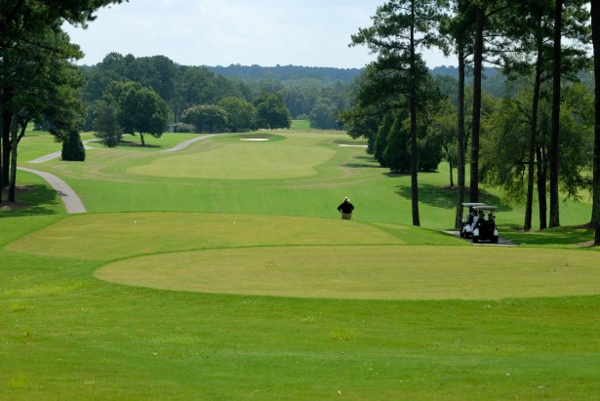

<https://www.publicdomainpictures.net/pictures/110000/nahled/golf-course-1417001883dme.jpg>

Platja

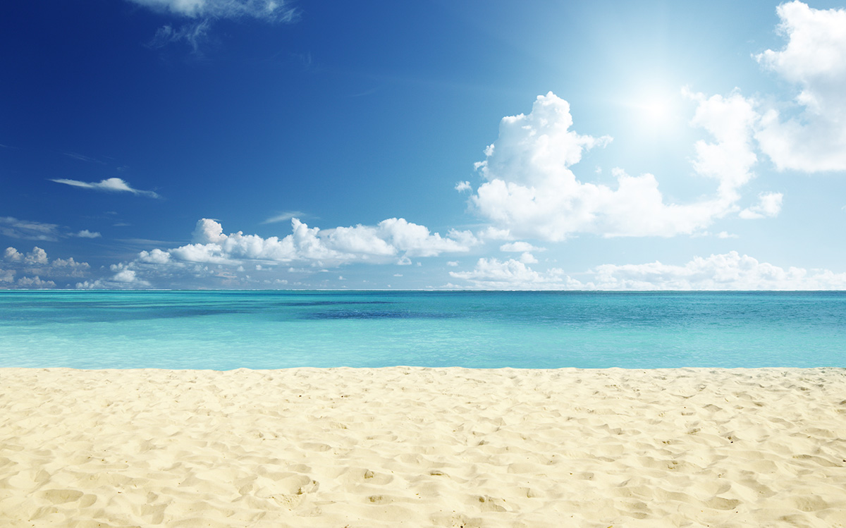

<https://twenergy.com/wp-content/uploads/2017/08/shutterstock_200624198.jpg>

Bolet:

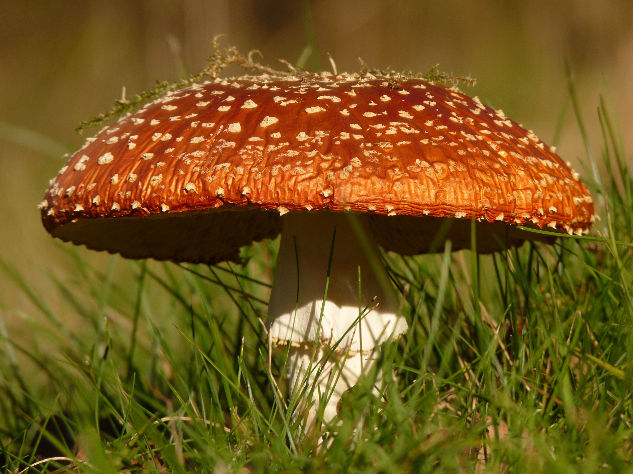

<https://images.pexels.com/photos/87784/fly-agaric-mushroom-gift-toxic-87784.jpeg>

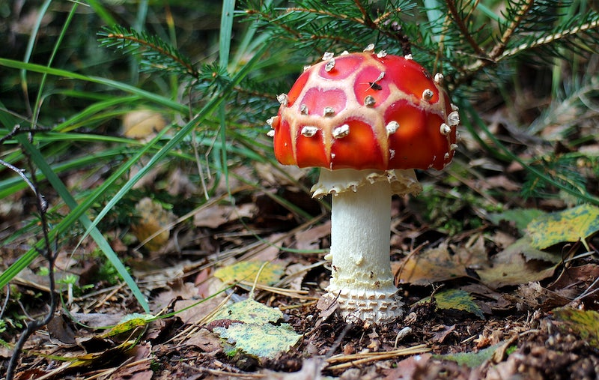

<https://img.rawpixel.com/s3fs-private/rawpixel_images/website_content/frfly_agaric_mushroom_forest_14-image-kybbheby.jpg?w=800&dpr=1&fit=default&crop=default&q=65&vib=3&con=3&usm=15&bg=F4F4F3&ixlib=js-2.2.1&s=0afec8756973e3b586dde739b7111030>

Gelat

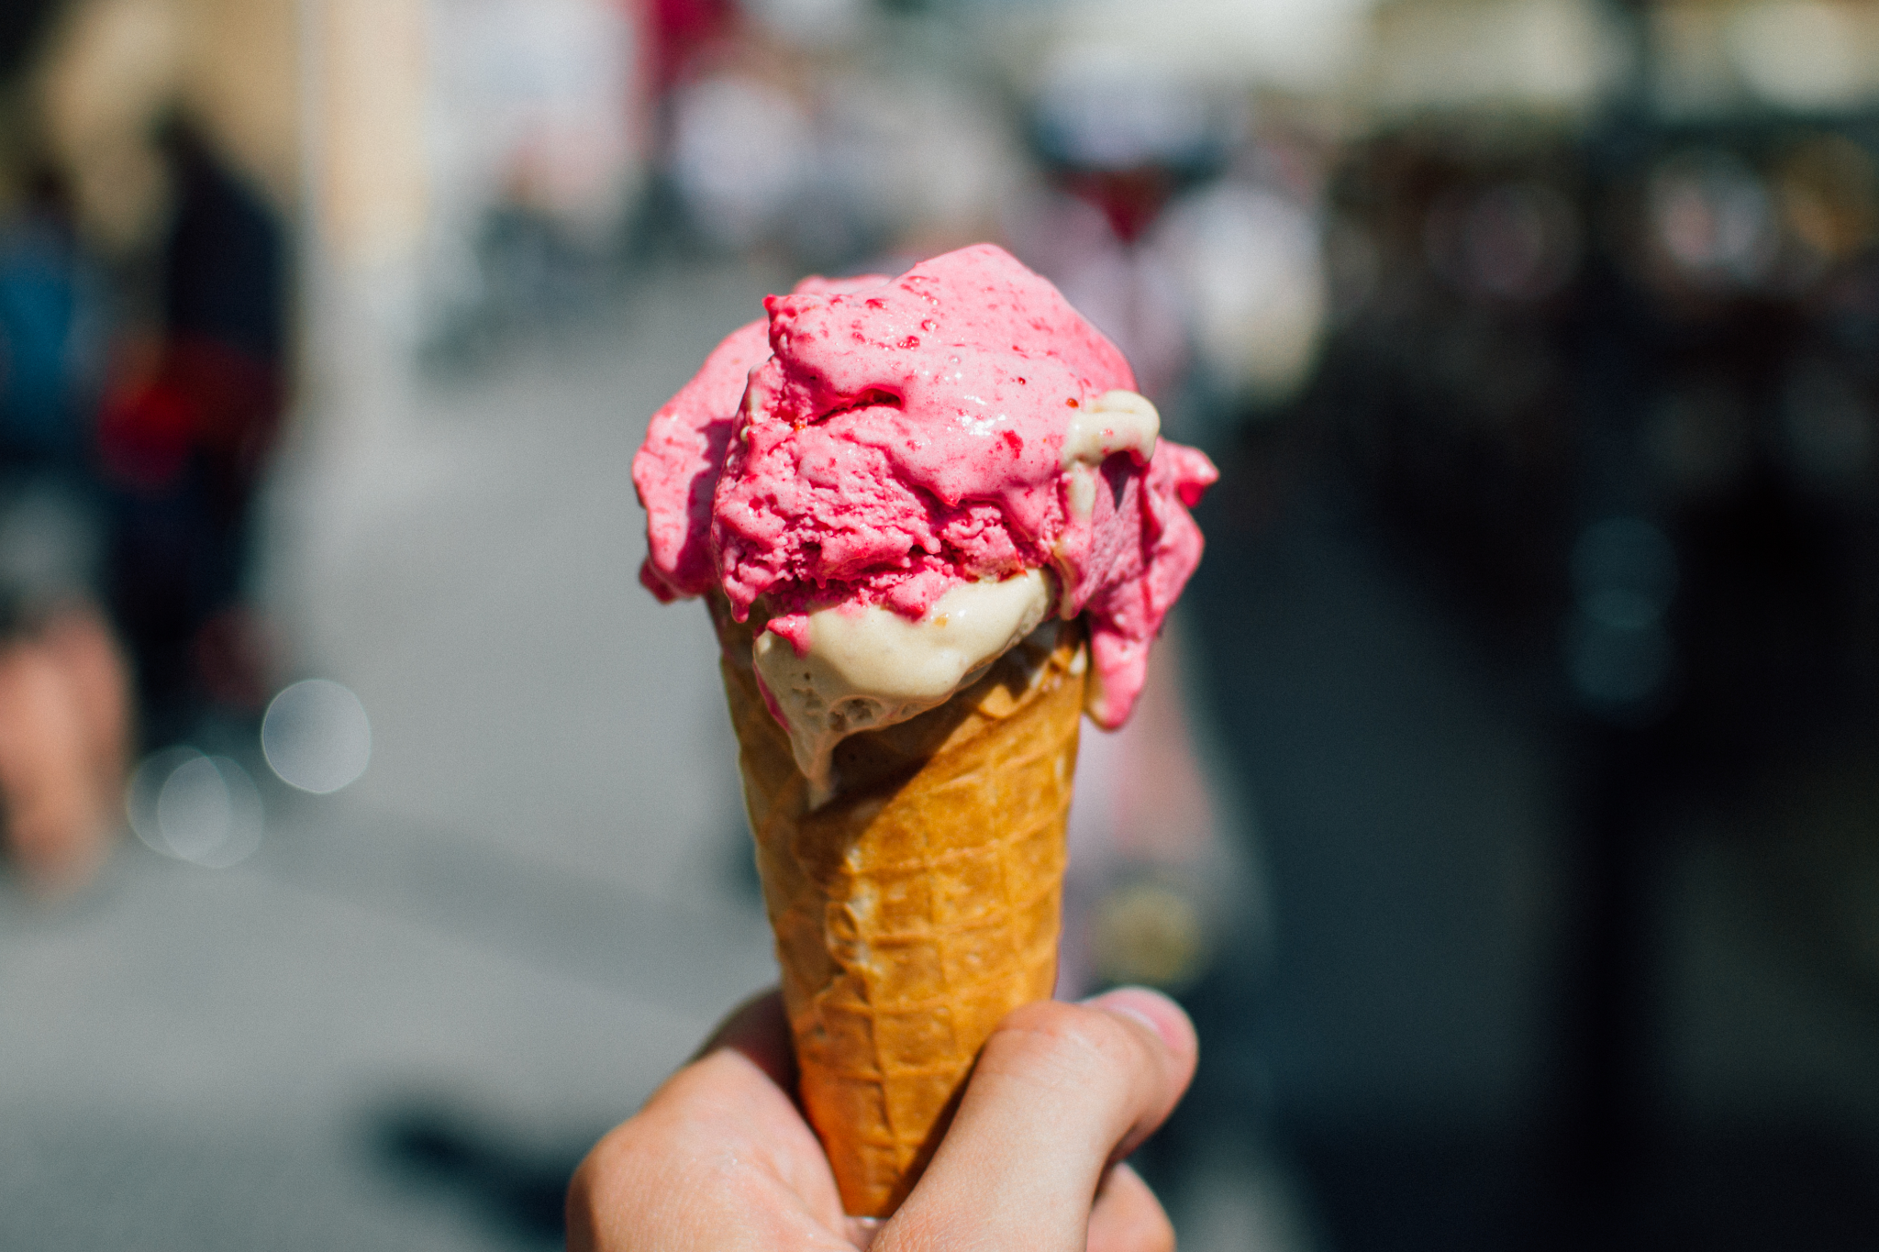

<https://upload.wikimedia.org/wikipedia/commons/4/45/Food-ice-cream_%2824244079871%29.jpg>

COVA

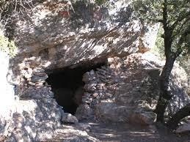

<https://www.google.com/url?sa=i&url=https%3A%2F%2Fcommons.wikimedia.org%2Fwiki%2FFile%3ACova_del_Rac%25C3%25B3_Gran_o_Cova_d%2527en_Tinet%2C_Parc_natural_de_Sant_Lloren%25C3%25A7_del_Munt_i_l%2527Obac_%2528desembre_2011%2529_-_panoramio.jpg&psig=AOvVaw2LVwAnnj9VH7LZRDMtRbSQ&ust=1669994607658000&source=images&cd=vfe&ved=0CBAQjRxqFwoTCMirlYHd2PsCFQAAAAAdAAAAABAD>

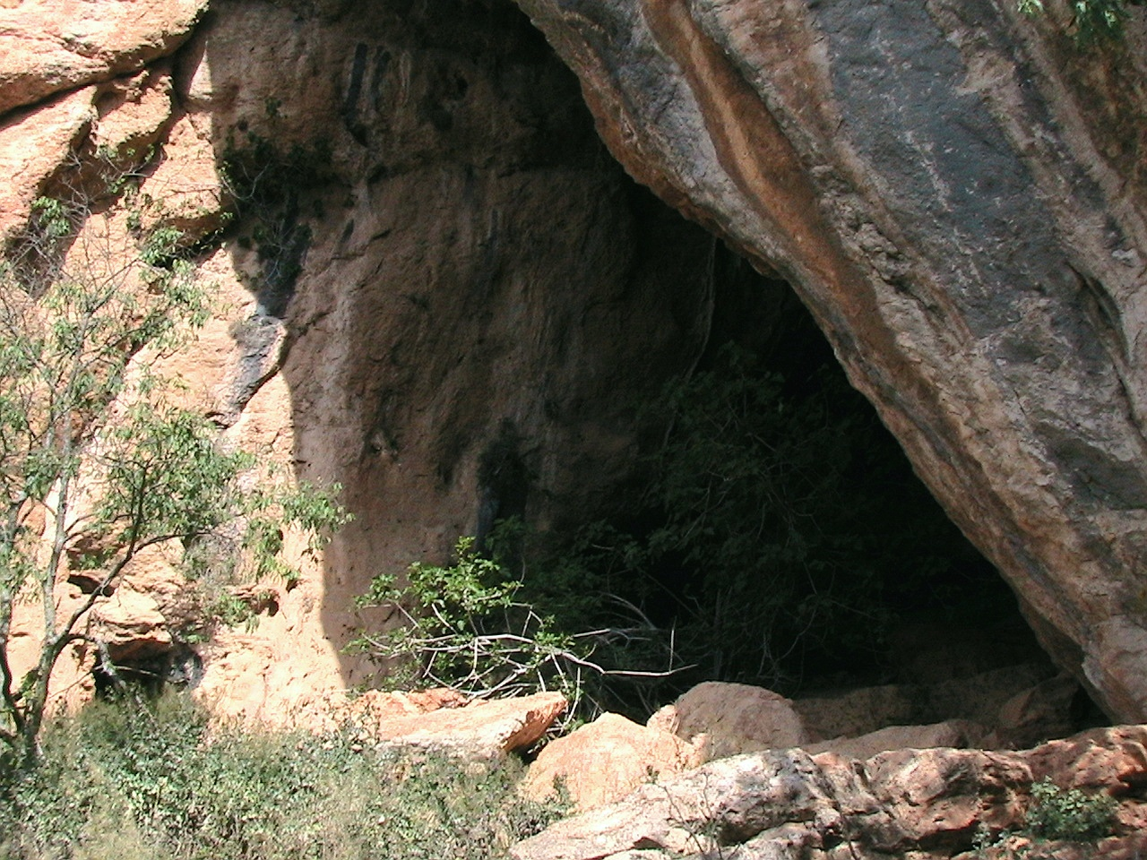

<https://www.google.com/url?sa=i&url=https%3A%2F%2Fcommons.wikimedia.org%2Fwiki%2FFile%3ACOVA_DEL_TABAC_-_CAMARASA_-_IB-074.JPG&psig=AOvVaw2LVwAnnj9VH7LZRDMtRbSQ&ust=1669994607658000&source=images&cd=vfe&ved=0CBAQjRxqFwoTCMirlYHd2PsCFQAAAAAdAAAAABAN>

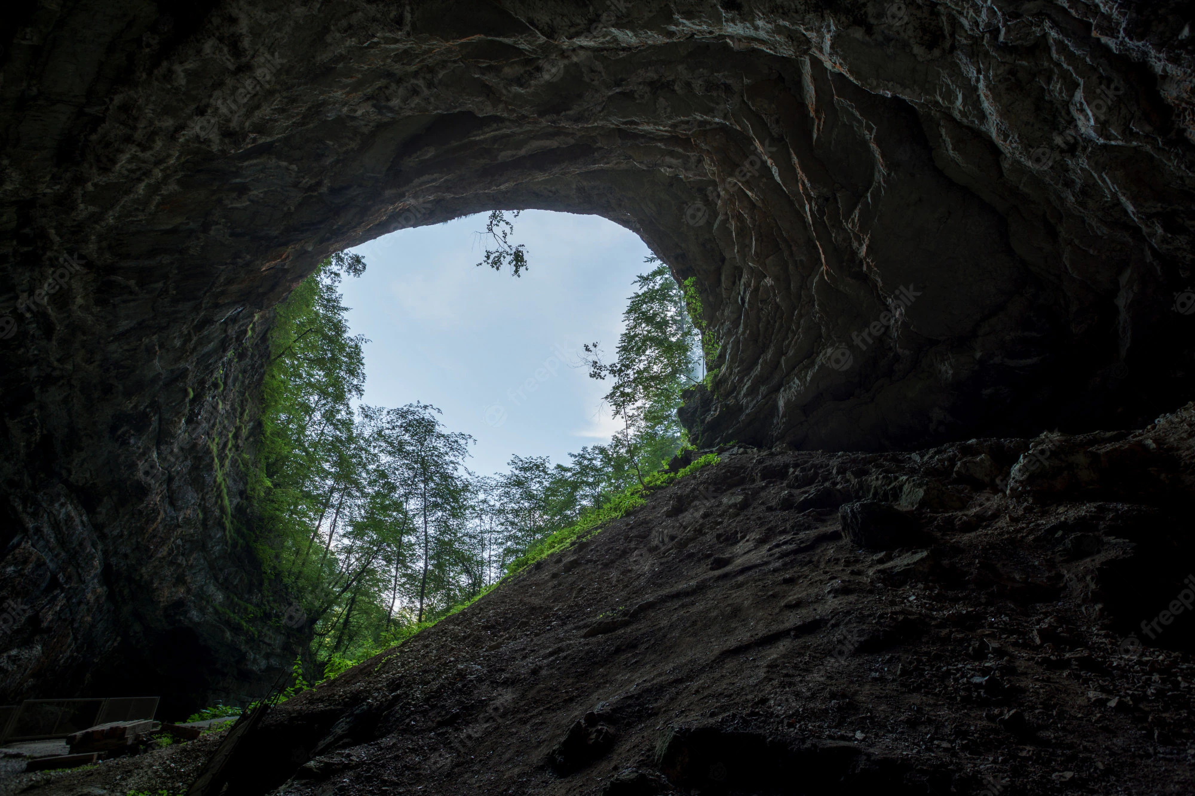

<https://img.freepik.com/foto-gratis/tiro-angulo-salida-cueva-oscura-skrad-croacia_181624-8266.jpg?w=2000>

ELEFANT

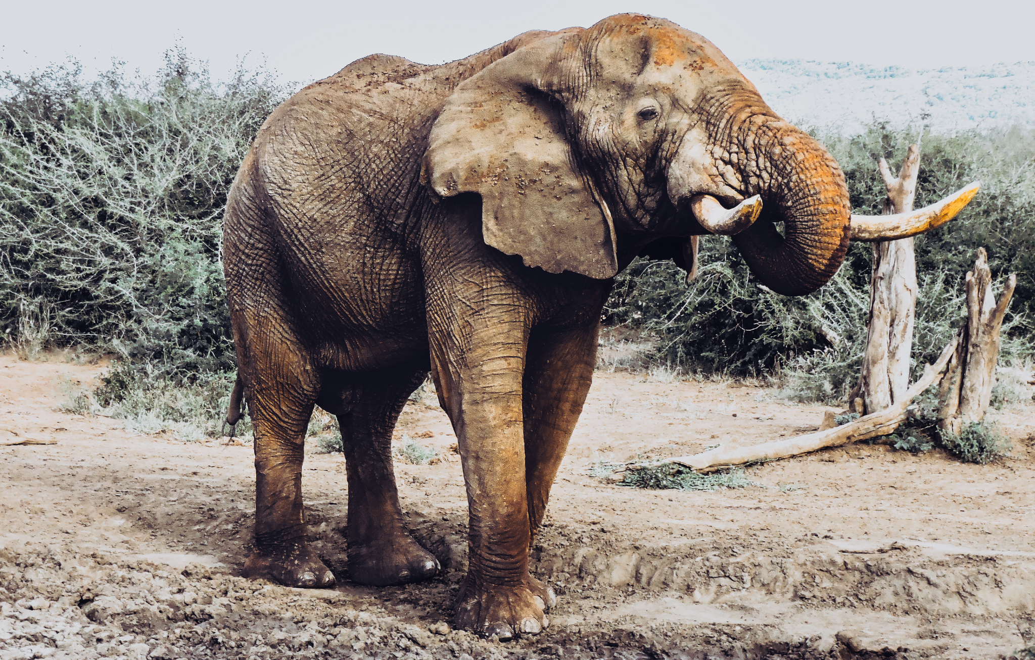

<https://www.google.com/url?sa=i&url=https%3A%2F%2Fwww.pexels.com%2Fca-es%2Ffoto%2Ftextura-animal-tronc-gran-5205058%2F&psig=AOvVaw2PpK1dyMXMLOPZNgjgL6OE&ust=1669994741581000&source=images&cd=vfe&ved=0CBAQjRxqFwoTCJD1uLDd2PsCFQAAAAAdAAAAABAF>

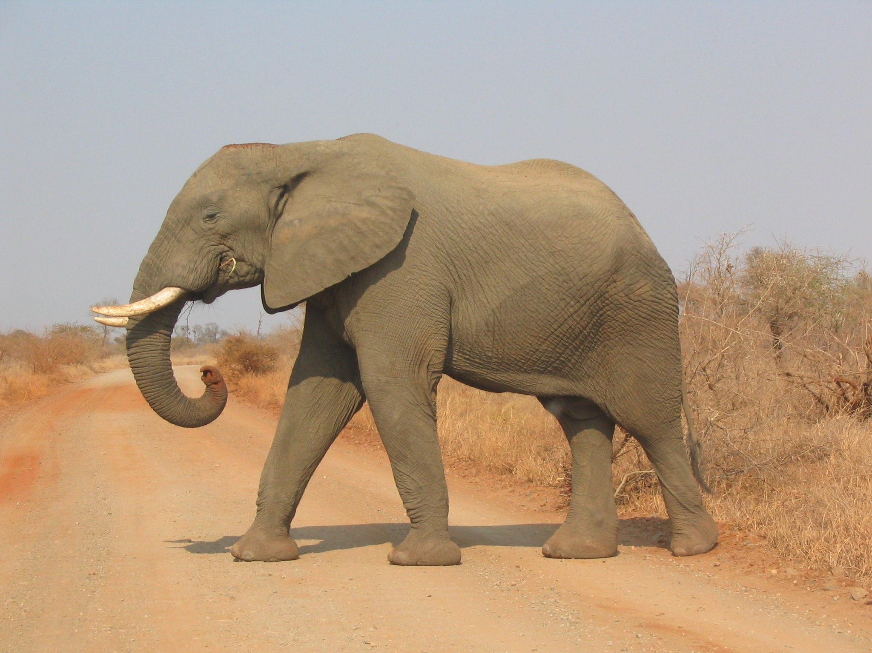

<https://www.google.com/url?sa=i&url=https%3A%2F%2Fcommons.wikimedia.org%2Fwiki%2FFile%3AElephant_side-view_Kruger.jpg&psig=AOvVaw17mk-419tqaHQdCvLdTtcY&ust=1669995120037000&source=images&cd=vfe&ved=0CBAQjRxqFwoTCNDKs-Te2PsCFQAAAAAdAAAAABAD>

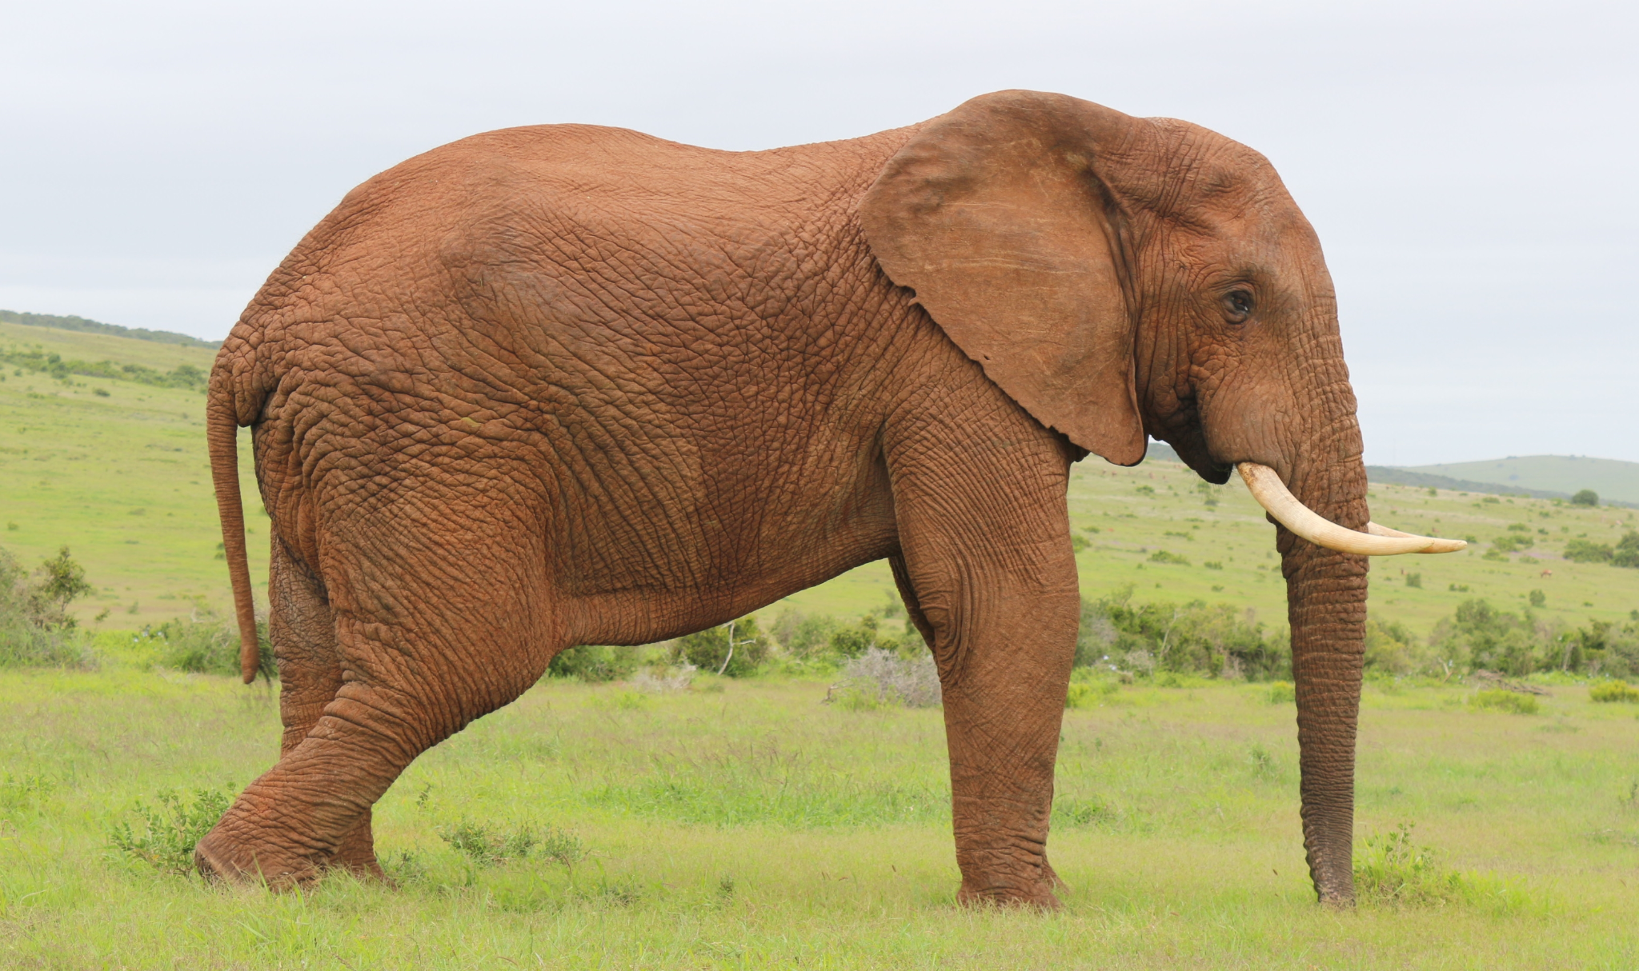

<https://images.pexels.com/photos/7621756/pexels-photo-7621756.jpeg>

Nen:

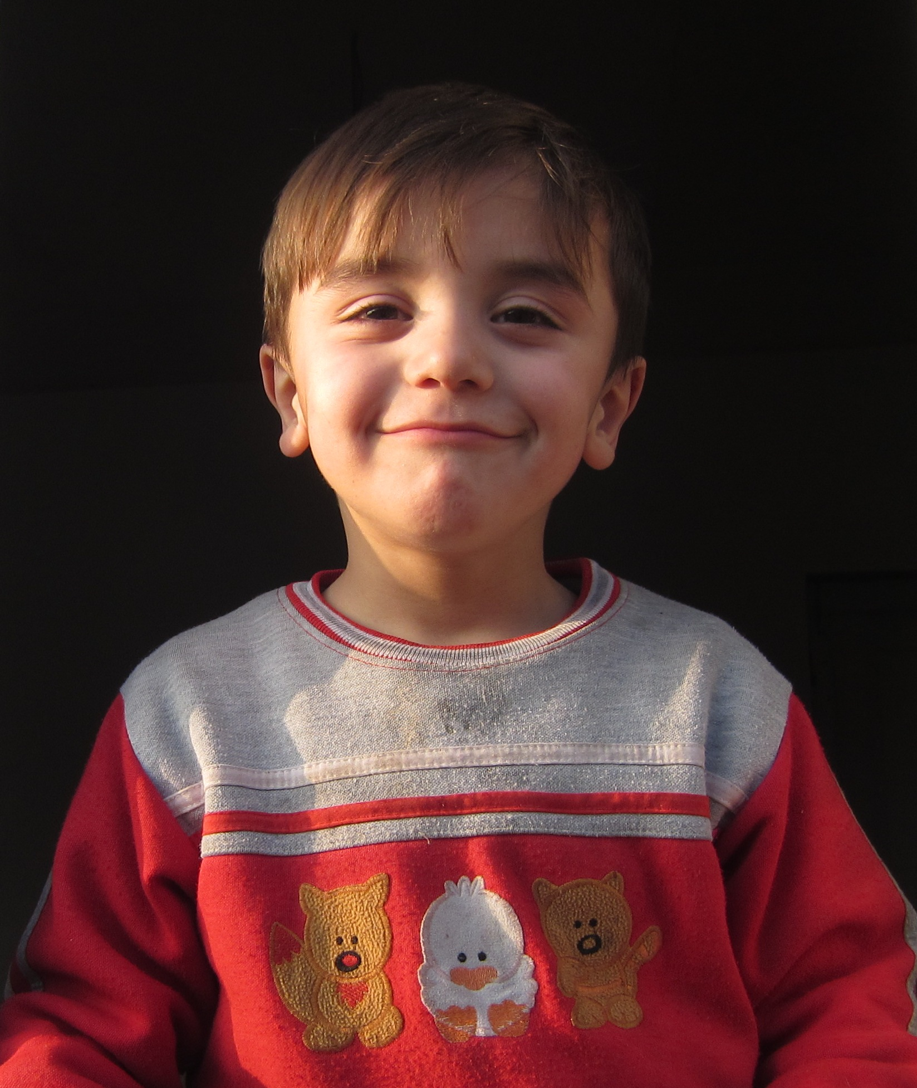

<https://upload.wikimedia.org/wikipedia/commons/0/09/Tsakhur_child_in_Qum_%28Azerbaijan%29.JPG>

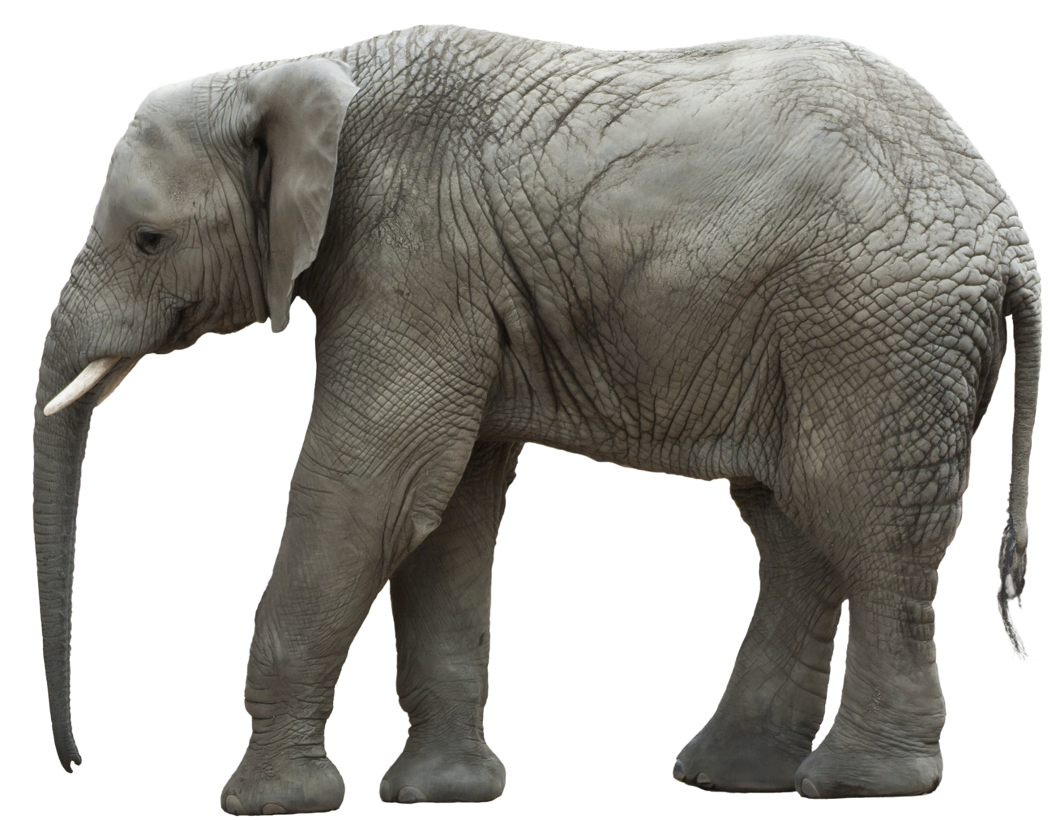

<https://www.google.com/url?sa=i&url=https%3A%2F%2Fcommons.wikimedia.org%2Fwiki%2FFile%3AFrilagd_elefant.jpg&psig=AOvVaw2PpK1dyMXMLOPZNgjgL6OE&ust=1669994741581000&source=images&cd=vfe&ved=0CBAQjRxqFwoTCJD1uLDd2PsCFQAAAAAdAAAAABAb>